Outstanding Native Plants for Birds in Central Virginia

In the last 50 years, songbird populations have declined by 30% due to a variety of causes. One major cause of this decline is a lack of food. Gardeners can help reverse this decline by planting native plants that provide food and shelter for birds. Native plants, especially keystone plants, provide more nutritious food than non-native plants. Keystone plants are critical to the food web and are essential for many wildlife species to complete their life cycle. According to Doug Tallamy, noted entomologist, a pair of chickadees need 6,000-9,000 caterpillars to successfully raise one clutch. Keystone plants support 90% of these vital caterpillars.
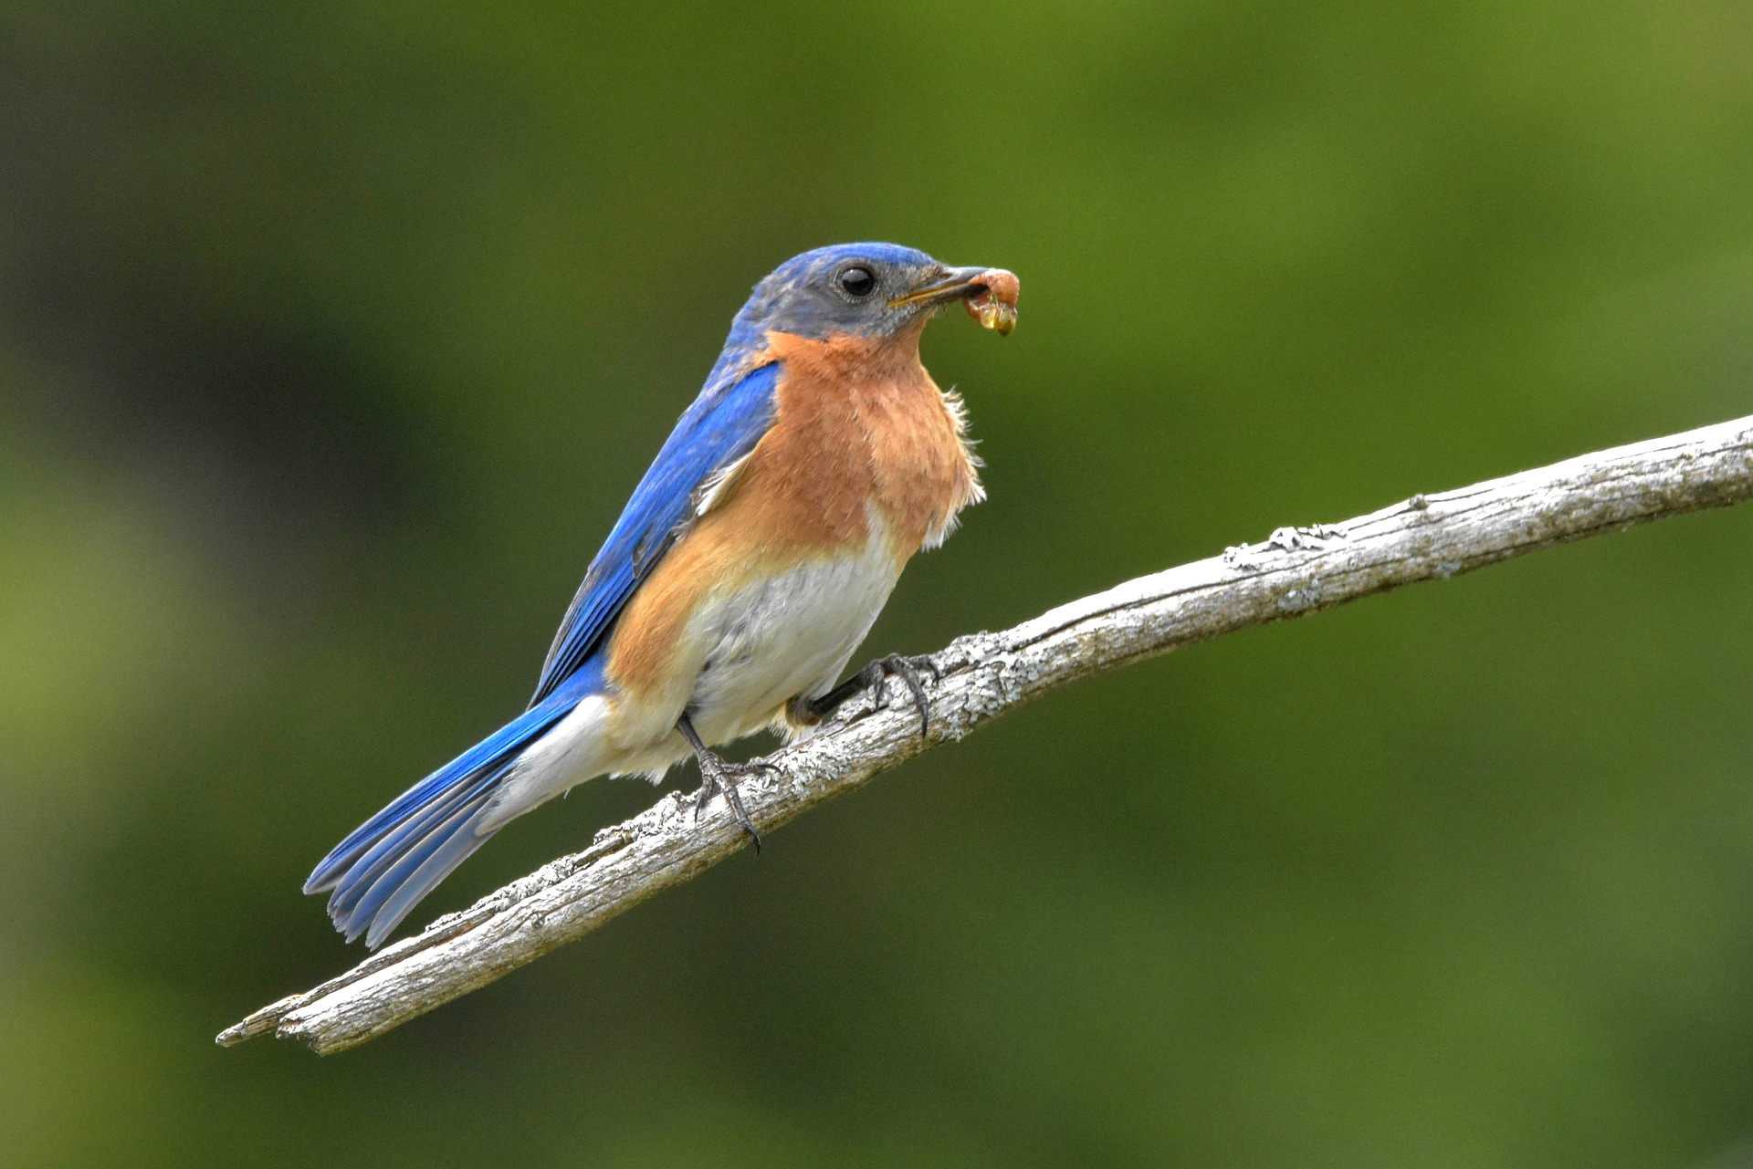

Bird species search for food in different areas; warblers look for bugs in the canopy layers, woodpeckers search for insects around tree trunks and sparrows forage for food on the ground. To increase bird diversity, plant in layers using canopy trees, understory trees, shrubs, herbaceous plants and groundcovers. Strive to include a variety of plants to provide food in the following categories: bugs, fruit, nuts/seeds and nectar. Below is an example of plant groupings that provide food for nesting, migrating and wintering birds in each season. Using 1-2 plants in each category will attract a variety of birds to your yard year around.

Plants that provide food year around for migrating, nesting and wintering birds.
 | spring | summer | fall | winter
Canopy | oaks native willows black cherry | oaks red maple river birch | oaks native cherries american beech | american holly eastern red cedar native pines
Understory | redbud serviceberry | native dogwood chokecherry | native dogwoods serviceberry | native dogwoods boxelder
Shrubs | spicebush blueberry | blueberry carolina rose native viburnums | spicebush sumacs bayberry | inkberry winterberry native viburnums
Vines | coral honeysuckle | coral honeysuckle | virginia creeper coral honeysuckle | virginia creeper
Wildflowers | virginia bluebells woodland phlox violets sedges | mountain mints beebalms  native sunflowers cardinal flower | goldenrods asters native sunflowers coneflowers | coneflowers liatris joe-pye weed sedges

On the next page is a chart which gives a more extensive list of outstanding plants for birds in central Virginia. Keystone plants, which are extremely important plants in a balanced ecosystem, are highlighted.

Terrific Native Plants for Birds in Central Virginia
Trees | Flowers
native oaks: white, willow, scarlet ** | asters: new england, aromatic, white wood, heart-leaved , calico, smooth
native birches: river, sweet | goldenrods: gray, showy, stiff, zigzag, sweet, wreath
native maples: red, boxelder | sunflower: woodland, narrow leaved, thinned leaved
native cherries: black, american plum, chokecherry | rudbeckia: orange coneflower, black-eyed susan, cutleaf coneflower
native willows: black, pussy, prairie | beebalm: scarlet, wild, spotted
native dogwoods: flowering, pagoda, silky | virginia bluebells
native pines: virginia, shortleaf, loblolly, | carolina rose
hickories: pignut, shagbark, mockernut ** | silphiums: cup plant, rosinweed
eastern redbud | mountain mint: hoary, short-toothed, virginia
serviceberry | echinacea: purple coneflower
american holly | phlox: woodland, moss, meadow
sassafras | new york ironweed, upland ironweed
eastern red cedar | lobelias: cardinal flower, blue lobelia
black gum | coreopsis: whorled, tall
Shrubs | joe-pye-weed
 | beardtongue
blueberry: highbush, lowbush | mistflower
chokeberry: red, black | liatris
viburnums: arrowwood, blackhaw, possum, mapleleaf | thoroughworts: hyssopleaf thoroughwort, boneset
 | maryland golden aster
spicebush | white snakeroot
sumacs: fragrant, winged, smooth | wild columbine
deciduous hollies: inkberry, winterberry | giant purple hyssop
ninebark | Groundcovers
azaleas: pinxter, flame
carolina rose | green and gold
sweetspire | violets: blue, cream, yellow
native hydrangea: oakleaf, wild, maple-leaf | robin's plantain
Vines | pussy toes
 | partridgeberry
virginia creeper | allegheny spurge
coral honeysuckle | lyre-leaved sage
virgin's bower | sedges: seersucker, pennsylvania, meadow, rosy
*Keystone plants are highlighted **Best grown from bare-rooted sapling or seed

