Attracting Hummingbirds to Your Garden
In early April, the beautiful Ruby-throated Hummingbird arrives in Virginia after journeying from Central America. The hummingbird, weighing less than a penny, travels 500 miles across the Gulf of Mexico in approximately 20 hours. During migration, the hummingbird’s heart beats up to 1,260 times per minute and its wings flap 15-18 times per second.
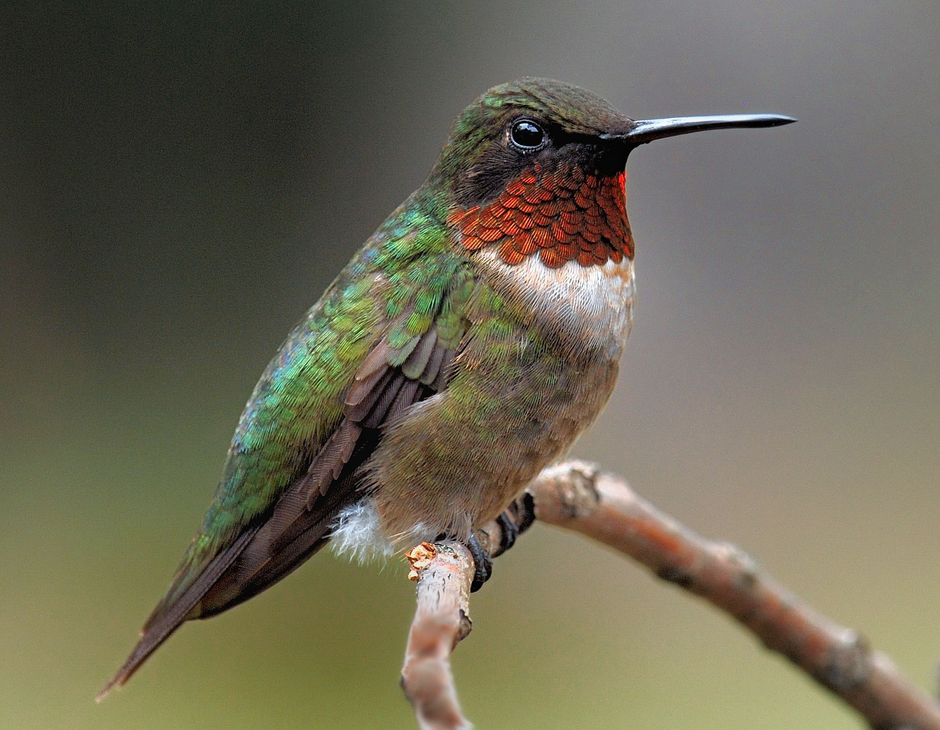

Why do the hummingbirds and other migrating birds undertake this perilous journey? They come here to raise their young. Migrating birds travel to North America for the abundant, rich diversity of insects. The major food source for young birds are insects, not seeds. Insects, especially young caterpillars, are rich in energy and protein.

An inviting habitat for hummingbirds provides several key features: shelter, nesting sites, nesting material, food and water. Trees and shrubs provide shelter and nesting sites. To build their nests, hummingbirds collect fibers from ferns, lichens and mosses. Several yards of spider web silk are used to glue all the fibers together to form their tiny nest. According to Doug Tallamy, a noted entomologist, 80% of the hummingbird’s diet comes from spiders and tiny insects such as aphids, mosquitoes, gnats and caterpillars. Only 20 % of their diet comes from nectar.

In the flower garden, hummingbirds search for tiny insects on flowers and glean insects from the air. They also sip nectar with a high sugar concentration from tubular flowers. Leave leaf litter in the garden. Leaf litter is the primary egg laying habitat for many small insects such as gnats. Spiders, caterpillars and larvae over-winter in the leaf litter.

Keep gardens free of pesticides because 96 % of terrestrial birds in North America depend upon insects for survival. A garden filled with native plants supports hummingbirds, songbirds and insects including those important insect pollinators.

Outstanding Hummingbird Plants for Central Virginia
Trees | redbud, tulip poplar, red maple, oaks, native cherries, native willows
Shrubs | blueberry, virginia sweetspire, pinxter azalea, buttonbush, new jersey tea
Vines | coral honeysuckle, trumpet vine, virgin's bower
Early Season Flowers | lyreleaf sage, virginia bluebells, woodland phlox, beardtongue
Mid-Season Flowers | wild columbine, bee balm, butterfly weed, meadow phlox, liatris
Late Season Flowers | cardinal flowers, native sunflowers, ironweed, goldenrods, native asters
Ground cover | leaf litter, moss, ferns, carex, cutleaf toothwort, hepatica

