Create a Bird Friendly Yard

Add native, keystone plants.
Native plants are superior to non-native plants in providing food for birds. The typical suburban yard with an expansive lawn and a few Japanese azaleas is an ecological desert for birds, offering little food or shelter. Keystone plants, like oak trees, are critical plants to the ecosystem. Keystone plants support 90% of the caterpillar species. Caterpillars are the major group of insects that transfer energy to birds and other animals. Terrestrial birds depend upon caterpillars to survive.

Remove invasive plants.
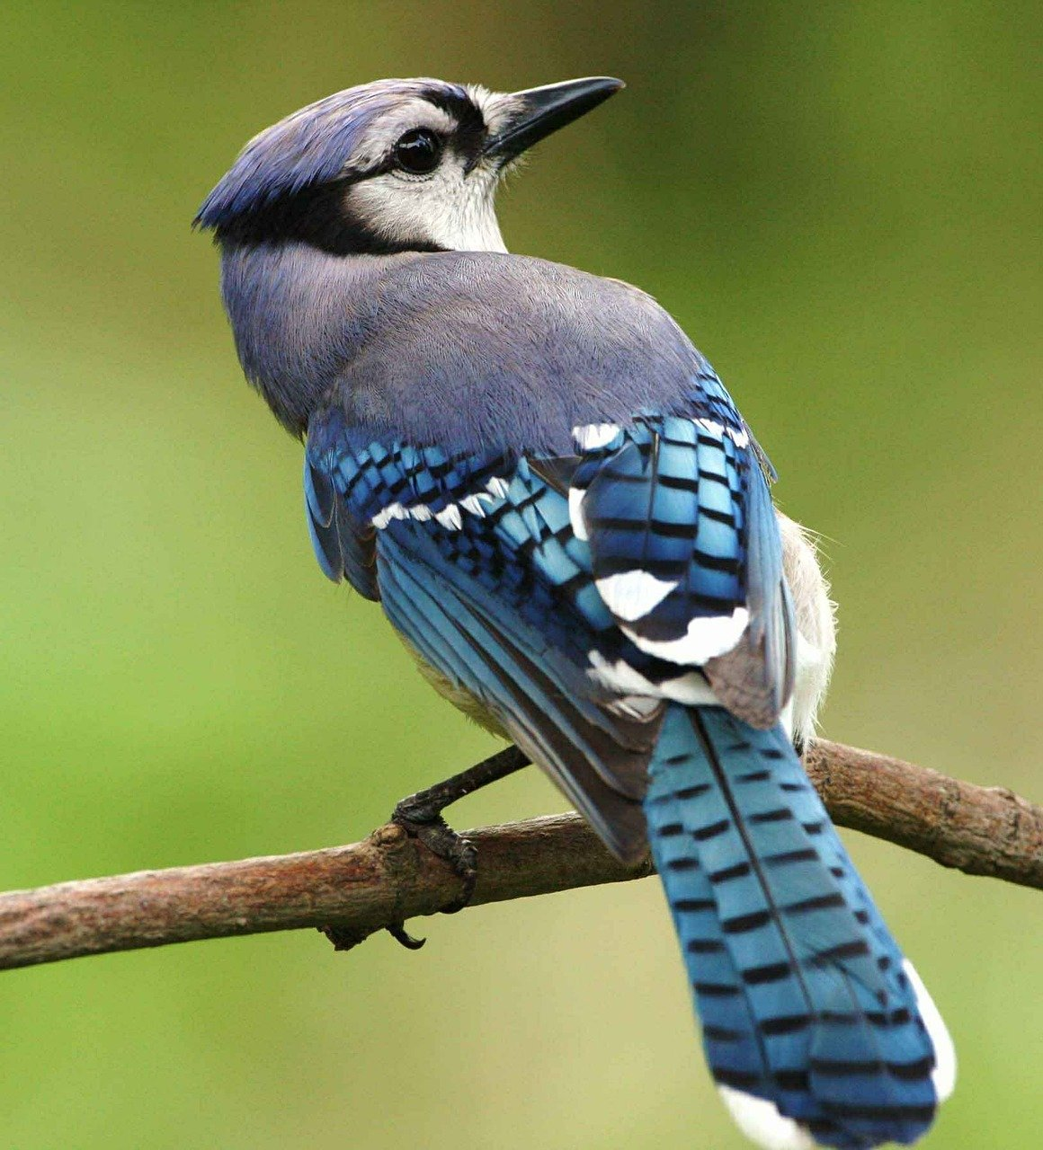
Invasive plants are nonnative plants that spread aggressively outside of our gardens displacing native plants. Most invasive plants cannot be used as food by native insects and produce nutrient poor food for birds.

Plant in layers.
Mimic a forest by creating layers, using trees, shrubs, vines and groundcovers. Include evergreens for shelter. Plant in clusters instead of individual species.

Protect insects.
Don’t use pesticides and herbicides. The use of insecticides is a major cause of insect decline.

Save fallen leaves!
Many insects and small arthropods live and hibernate in the leaf litter. Decomposing leaf litter enriches the soil for beneficial microorganisms, which help plants grow. Use leaves to mulch flower beds or to kill grass when shrinking lawns. A 2-3 inches layer of leaves does not smother emerging plants. Harwood mulch is better than bare ground but not as beneficial as leaves. Skip the expense of adding chemical fertilizer to the lawn, naturally fertilize lawns by shredding leaves with a mower. Make a compost pile with leaves.

Be a messy gardener.
Leave dead foliage and stems in the garden until spring. Seed heads provide critical food for birds during the winter. Insects hibernating in dead plant foliage is an important food source for birds. Leave dead snags and limbs in the yard. Dead snags serve as insect hotels for many years and provide nesting cavities for bluebirds and woodpeckers.
Keep cats indoors!
Outdoor Cats are the #1 predator of songbirds around our homes. According to the American Bird Conservancy, outdoor cats kill 2.4 billion birds each year

Turn off exterior lights.
Bright exteriors lights disrupt songbird migration. Nocturnal moths and fireflies, a major food source for breeding birds, are declining due in part to exposure to bright lights. Bright lights disorient insects. Consider using motion detector lights or lower wattage lights.

